**DevOps Assignments**

**Assignment 1**

1. **What is your understanding of a DevOps Culture in an Organization?**

A DevOps culture involves closer collaboration and a shared responsibility between development and operations for the products they create and maintain. It means increasing transparency, communication, and collaboration across development, IT/operations, and "the business".

It is a set of values and practices that brings people together to solve complex problems. It emphasizes collaboration, communication, and continuous learning. DevOps is about creating a shared understanding of the business objectives and ensuring that everyone is working towards the same goal.

**Pillars of DevOps**

**Culture**: DevOps culture revolves around culture as its first pillar. Culture is the basis on which everything else is built. Development and operations teams can collaborate, communicate, and integrate with a robust DevOps culture. It also encourages a focus on continuous improvement and customer satisfaction.

**Automation**: The second pillar of DevOps culture is automation. Automation helps to speed up the software delivery process by automating repetitive tasks and eliminating manual errors. Automation also allows teams to focus on more strategic tasks, such as improving the quality of the codebase or adding new features.

**Metrics**: The third pillar of DevOps culture is metrics. Metrics help measure the team’s speed, quality, and reliability success. Additionally, they provide feedback to improve the process. Several metrics are commonly used, including lead time, mean time to repair, and mean time to recover.

**Sharing**: The fourth pillar of DevOps culture is sharing. Sharing knowledge and best practices across the organization helps to improve the quality of the software delivered and speeds up the process. It also helps to build a community of practice that can share lessons learned and support others.

**Benefits of Embracing DevOps Culture**

* It improves an organization’s software development and delivery process.
* Reduces errors and improve software quality, organizations can achieve faster software development cycles, [increased collaboration](https://www.rocket.chat/blog/open-source-collaboration-software) between development and operations teams, and improved organizational communication.
* Reduces costs and improve quality, DevOps culture also makes an organization more agile and responsive. This is because DevOps emphasizes continuous improvement and rapid feedback loops.

1. **List and explain some of the IT tools you need to know to be a good DevOps engineer**

* **Gitlab/GitHub/Bitbucket:** These are the source code management repositories where you can store your code, do version control, and overall management of it.
* **Jenkins + Jenkins Plugins**: This is used for CI/CD, Jenkins might be the most commonly used by many tech companies. The advantage of using Jenkins over other pipeline tools is that it is first of all open-source and it has a lot of plugins that will make your things so easy to implement.
* **Docker:** Docker is a tool that allows developers to create a lightweight and portable software container that make application development, testing, and deployment easier.
* **Cloud Platforms:** This helps to create great infrastructure, we have three major platforms: AWS (Amazon Web Services), GCP (Google Cloud Platform) and Microsoft Azure.
* **Terraform and Ansible:** They are used for configuration management and orchestration. Terraform delivers Infrastructure as Code quickly, allowing for faster environment installation and development. While Ansible is majorly used to perform these two tasks: writing instructions on the way to install applications and designing the templates of configuration files.
* **Kubernetes**: Kubernetes is an open-source framework for managing containerized workloads and services that allows declarative configuration as well as automation.

1. Draw up a Software development Life Cycle Identifying where DevOps fit in.

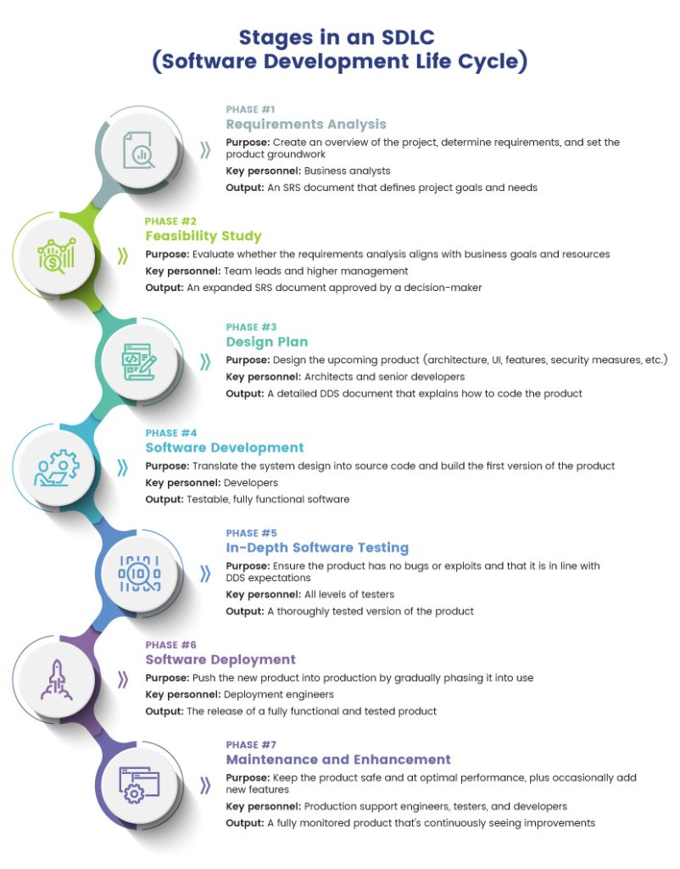

1. Draw up a DevOps process and explain what each represents.

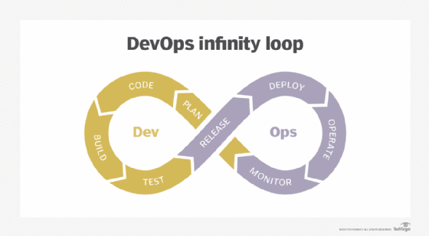

**Assignment 2**

1. Describe Hub, Switch and Router:

* Hub: This is a device that splits network connection into multiple computers.
* Switch: This allows devices on a network to communicate with each other as well as with other networks.
* Router: This helps me to connect with multiple networks i.e to share a single internet connection with multiple devices.

1. What is the OSI model?

OSI (Open Systems Interconnection) model is a reference model which allows you to specify standards for communication.

1. Explain the different layers of the OSI model.

* Physical Layer: This represents the electrical and physical representation of the system, which includes cable, layout pins etc.
* Data Link: This provides node-to-node data transfer and also handles error correction from the physical layer.
* Network: This is responsible for packet forwarding, including routing through different routers.
* Transport: This deals with the coordination of data transfer between end systems and hosts i.e how much data to send, at what rate, where it goes etc.
* Session: Functions at this layer involves setup, coordination(how long should a system wait for a response) and termination between the applications at each end of the session.
* Presentation: It represents the preparation or translation of application format i.e it presents data for the application or the network.
* Application: This receives information directly from the end users and displays incoming data to the user.

1. What do you mean by the TCP/IP Model?

TCP/IP Model stands for TCP/IP stands for Transmission Control Protocol/Internet Protocol. TCP/IP is a set of standardized rules that allow computers to communicate on a network such as the internet. TCP/IP protocol suite functions as an abstraction layer between internet applications and the routing and switching fabric.

1. What do you mean by HTTP, TCP and UDP

* HTTP: The Hypertext Transfer Protocol (HTTP) is the foundation of the World Wide Web, and is used to load webpages using hypertext links. HTTP is an [application layer](https://www.cloudflare.com/learning/ddos/application-layer-ddos-attack/) protocol designed to transfer information between networked devices and runs on top of other layers of the network [protocol](https://www.cloudflare.com/learning/network-layer/what-is-a-protocol/) stack. A typical flow over HTTP involves a client machine making a request to a server, which then sends a response message.
* TCP: Transmission Control protocol lies between the Application and Network Layers which are used in providing reliable delivery services. It is a connection-oriented protocol for communications that helps in the exchange of messages between different devices over a network.
* UDP: The User Datagram Protocol, or UDP, is a communication protocol used across the Internet for especially time-sensitive transmissions such as [video playback](https://www.cloudflare.com/learning/video/what-is-streaming/) or [DNS](https://www.cloudflare.com/learning/dns/what-is-dns/) lookups. It speeds up communications by not formally establishing a connection before data is transferred. This allows data to be transferred very quickly

1. What is a Firewall?

A Firewall is a network security device that monitors and filters incoming and outgoing network traffic based on an organization’s previously established security policies.

1. Explain DNS

The Domain Name System is the phonebook of the Internet. The process of DNS resolution involves converting a hostname (such as www.example.com) into a computer-friendly IP address (such as 192.168.1.1). An IP address is given to each device on the Internet, and that address is necessary to find the appropriate Internet device - like a street address is used to find a particular home. When a user wants to load a webpage, a translation must occur between what a user types into their web browser (example.com) and the machine-friendly address necessary to locate the example.com webpage.

1. Define Latency

Latency is the literal time it takes for a packet of data to go from its origination and reach its destination.

1. Define caching

It’s the process of storing copies of files in a cache, or temporary storage location, so that they can be accessed more quickly.

1. Explain Wireless Access point

A Wireless Access Point (WAP) is a networking device that allows connecting the devices with the wired network.